**Assignment 5**

Q Wap to convert Fahrenheit to Celsius  in Java using formula given below  
  
  °C = (°F – 32) / (9/5)

**package** project5;

**import** java.util.Scanner;

**public** **class** celtofafrenite {

**public** **static** **void** main(String[] args) {

**int** fahrenhit;

**int** celsius;

Scanner s = **new** Scanner(System.***in***);

System.***out***.println("Enter fahrenhit ");

fahrenhit=s.nextInt();

celsius=(fahrenhit-32)*5/9;

System.***out***.println(celsius);

}

}

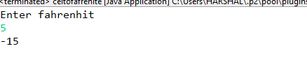

Q 2 wap to check a given number is armstrong or not  i.e. 153 = 1*1*1  + 5*5*5+3*3*3

**package** project5;

**import** java.util.Scanner;

**public** **class** Armstrong {

**public** **static** **void** main(String[] args) {

**int** n,r,c,temp;

**int** sum=0;

Scanner s = **new** Scanner(System.***in***);

System.***out***.println("enter value of n");

n=s.nextInt();

temp=n;

**while**(n>0)

{

r=n%10;

c=r*r*r;

sum=sum+c;

n=n/10;

}

n=temp;

**if**(n==sum)

System.***out***.println("No is armstrong");

**else**

System.***out***.println("No is not armstrong");

}

}

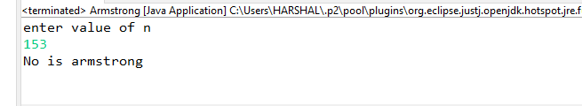

Q 3 Rajan  went to a movie with his friends in a multiplex theatre and during  break time he bought pizzas, puffs and cool drinks. Consider   the following prices :  
  
Rs.100/pizza  
Rs.20/puffs  
Rs.10/cooldrink  
Generate a bill for What Rajan  has bought.

**package** project5;

**import** java.util.Scanner;

**public** **class** multiplex {

**public** **static** **void** main(String[] args) {

**int** pizza;

**int** puffs;

**int** colddrinks;

Scanner s=**new** Scanner(System.***in***);

System.***out***.println("enter no. of pizzas bought:");

pizza=s.nextInt();

System.***out***.println("enter no. of puffs bought:");

puffs=s.nextInt();

System.***out***.println("enter no. of colddrinks bought:");

colddrinks=s.nextInt();

**int** Totalprice=pizza*100+puffs*20+colddrinks*10;

System.***out***.println("No of pizzas:"+pizza);

System.***out***.println("No of pizzas:"+puffs);

System.***out***.println("No of pizzas:"+colddrinks);

System.***out***.println("Total price=" +" "+Totalprice);

}

}

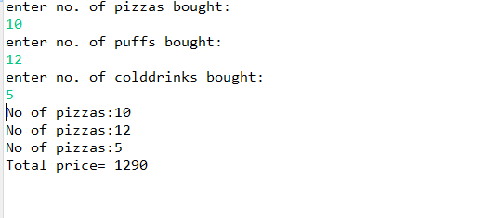

Q 3 Given an integer U denoting the amount of KWh units of electricity consumed, the task is to calculate the electricity bill with the help of the below charges:  
   
  
1 to 100 units – Rs. 10/unit  
100 to 200 units – Rs. 15/unit  
200 to 300 units – Rs. 20/unit  
above 300 units – Rs. 25/unit

**package** project5;

**import** java .util.Scanner;

**public** **class** Electricity {

**public** **static** **void** main(String[] args) {

**int** u;

**int** choice;

**int** Bill;

Scanner s = **new** Scanner(System.***in***);

System.***out***.println("Enter value of u");

u=s.nextInt();

**if**(u>=0&&u<=100)

choice=1;

**else** **if**(u>100&&u<=200)

choice=2;

**else** **if**(u>200&&u<=300)

choice=3;

**else**

choice=4;

**switch**(choice)

{ **case** 1:

Bill =u*10;

System.***out***.println("Total electricity bill="+" "+Bill);

**break**;

**case** 2:

Bill =(1000)+(15*(u-100));

System.***out***.println("Total electricity bill="+" "+Bill);

**break**;

**case** 3:

Bill =(1000)+(1500)+(20*(u-200));

System.***out***.println("Total electricity bill="+" "+Bill);

**break**;

**case** 4:

Bill =(1000)+(1500)+(2000)+(25*(u-300));

System.***out***.println("Total electricity bill="+" "+Bill);

**break**;

}

}

}

